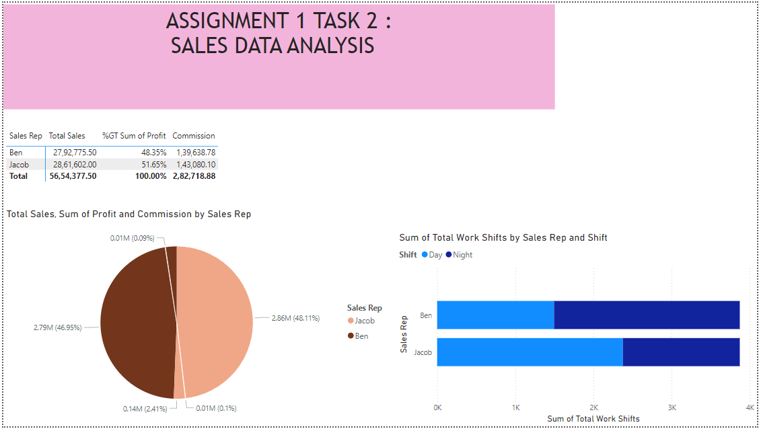

**Areas for Further Improvement:** Ben has to be increase their work on day shifts and Jacon has to be increase their work on night shift which further boost the sales of both.

**Work Shift Analysis:** Ben mostly work on night shifts while Jacob mostly works on day shifts.

**Additional Impact:**Both of them (Jacob and Ben) works for the same number of shifts but the Jacob sales was more than the Ben ,which shows that the Day shift was more productive than night shifts.